Name: Date: Block: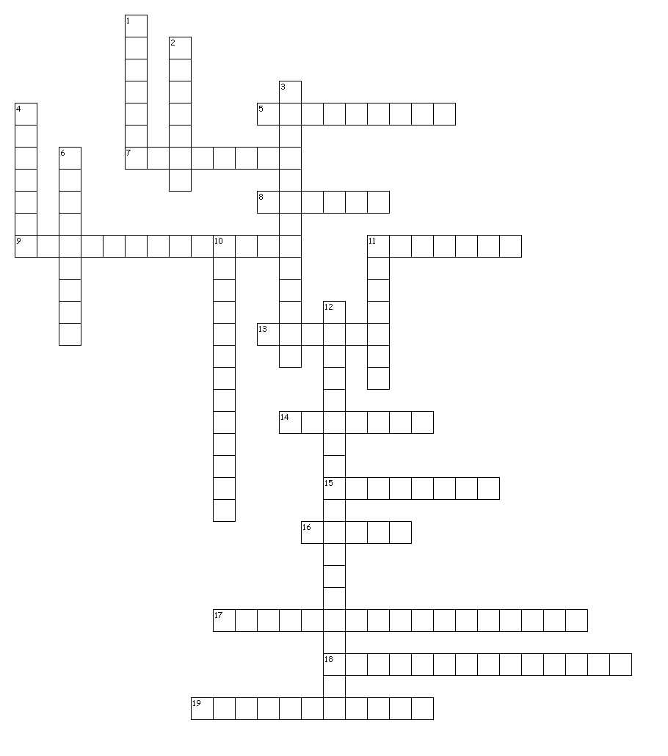

Holocaust Vocab

Across
5. an ideal race based on a Scandinavian blond, blue-eyed appearance
7. minister of propaganda
8. the first concentration camp opened in Germany
9. the paramilitary organization most responsible for the genocidal killing of Jews
11. belief that the Jews need to reestablish a homeland in historic Israel
13. segregated neighborhoods for Jews within cities in occupied territory
14. leader of human medical experimentation and in charge of Auschwitz gas chambers
15. term for racial "purification" favored by Social Darwinists
16. Jews in the camps who earned privileges by acting as wardens or work supervisors
17. meeting in which the Nazi leadership agreed to the Final Solution
18. mobile killing units
19. religious symbol repurposed as Jewish badge

Down
1. founder of the gestapo and president of the reichstag
2. he set up and controlled the concentration camps, death camps, and einsatzgruppen
3. the "night of broken glass"
4. violent riots with the aim of attacking and killing Jews
6. the most infamous network of concentration and death camps, eventually liberated by the Allies
10. euphemism for plan to kill off the Jews
11. pesticide used in gas chambers
12. english translation; idea that certain minority groups and political leaders are to blame for Germany's WWI loss and subsequent misfortunes

